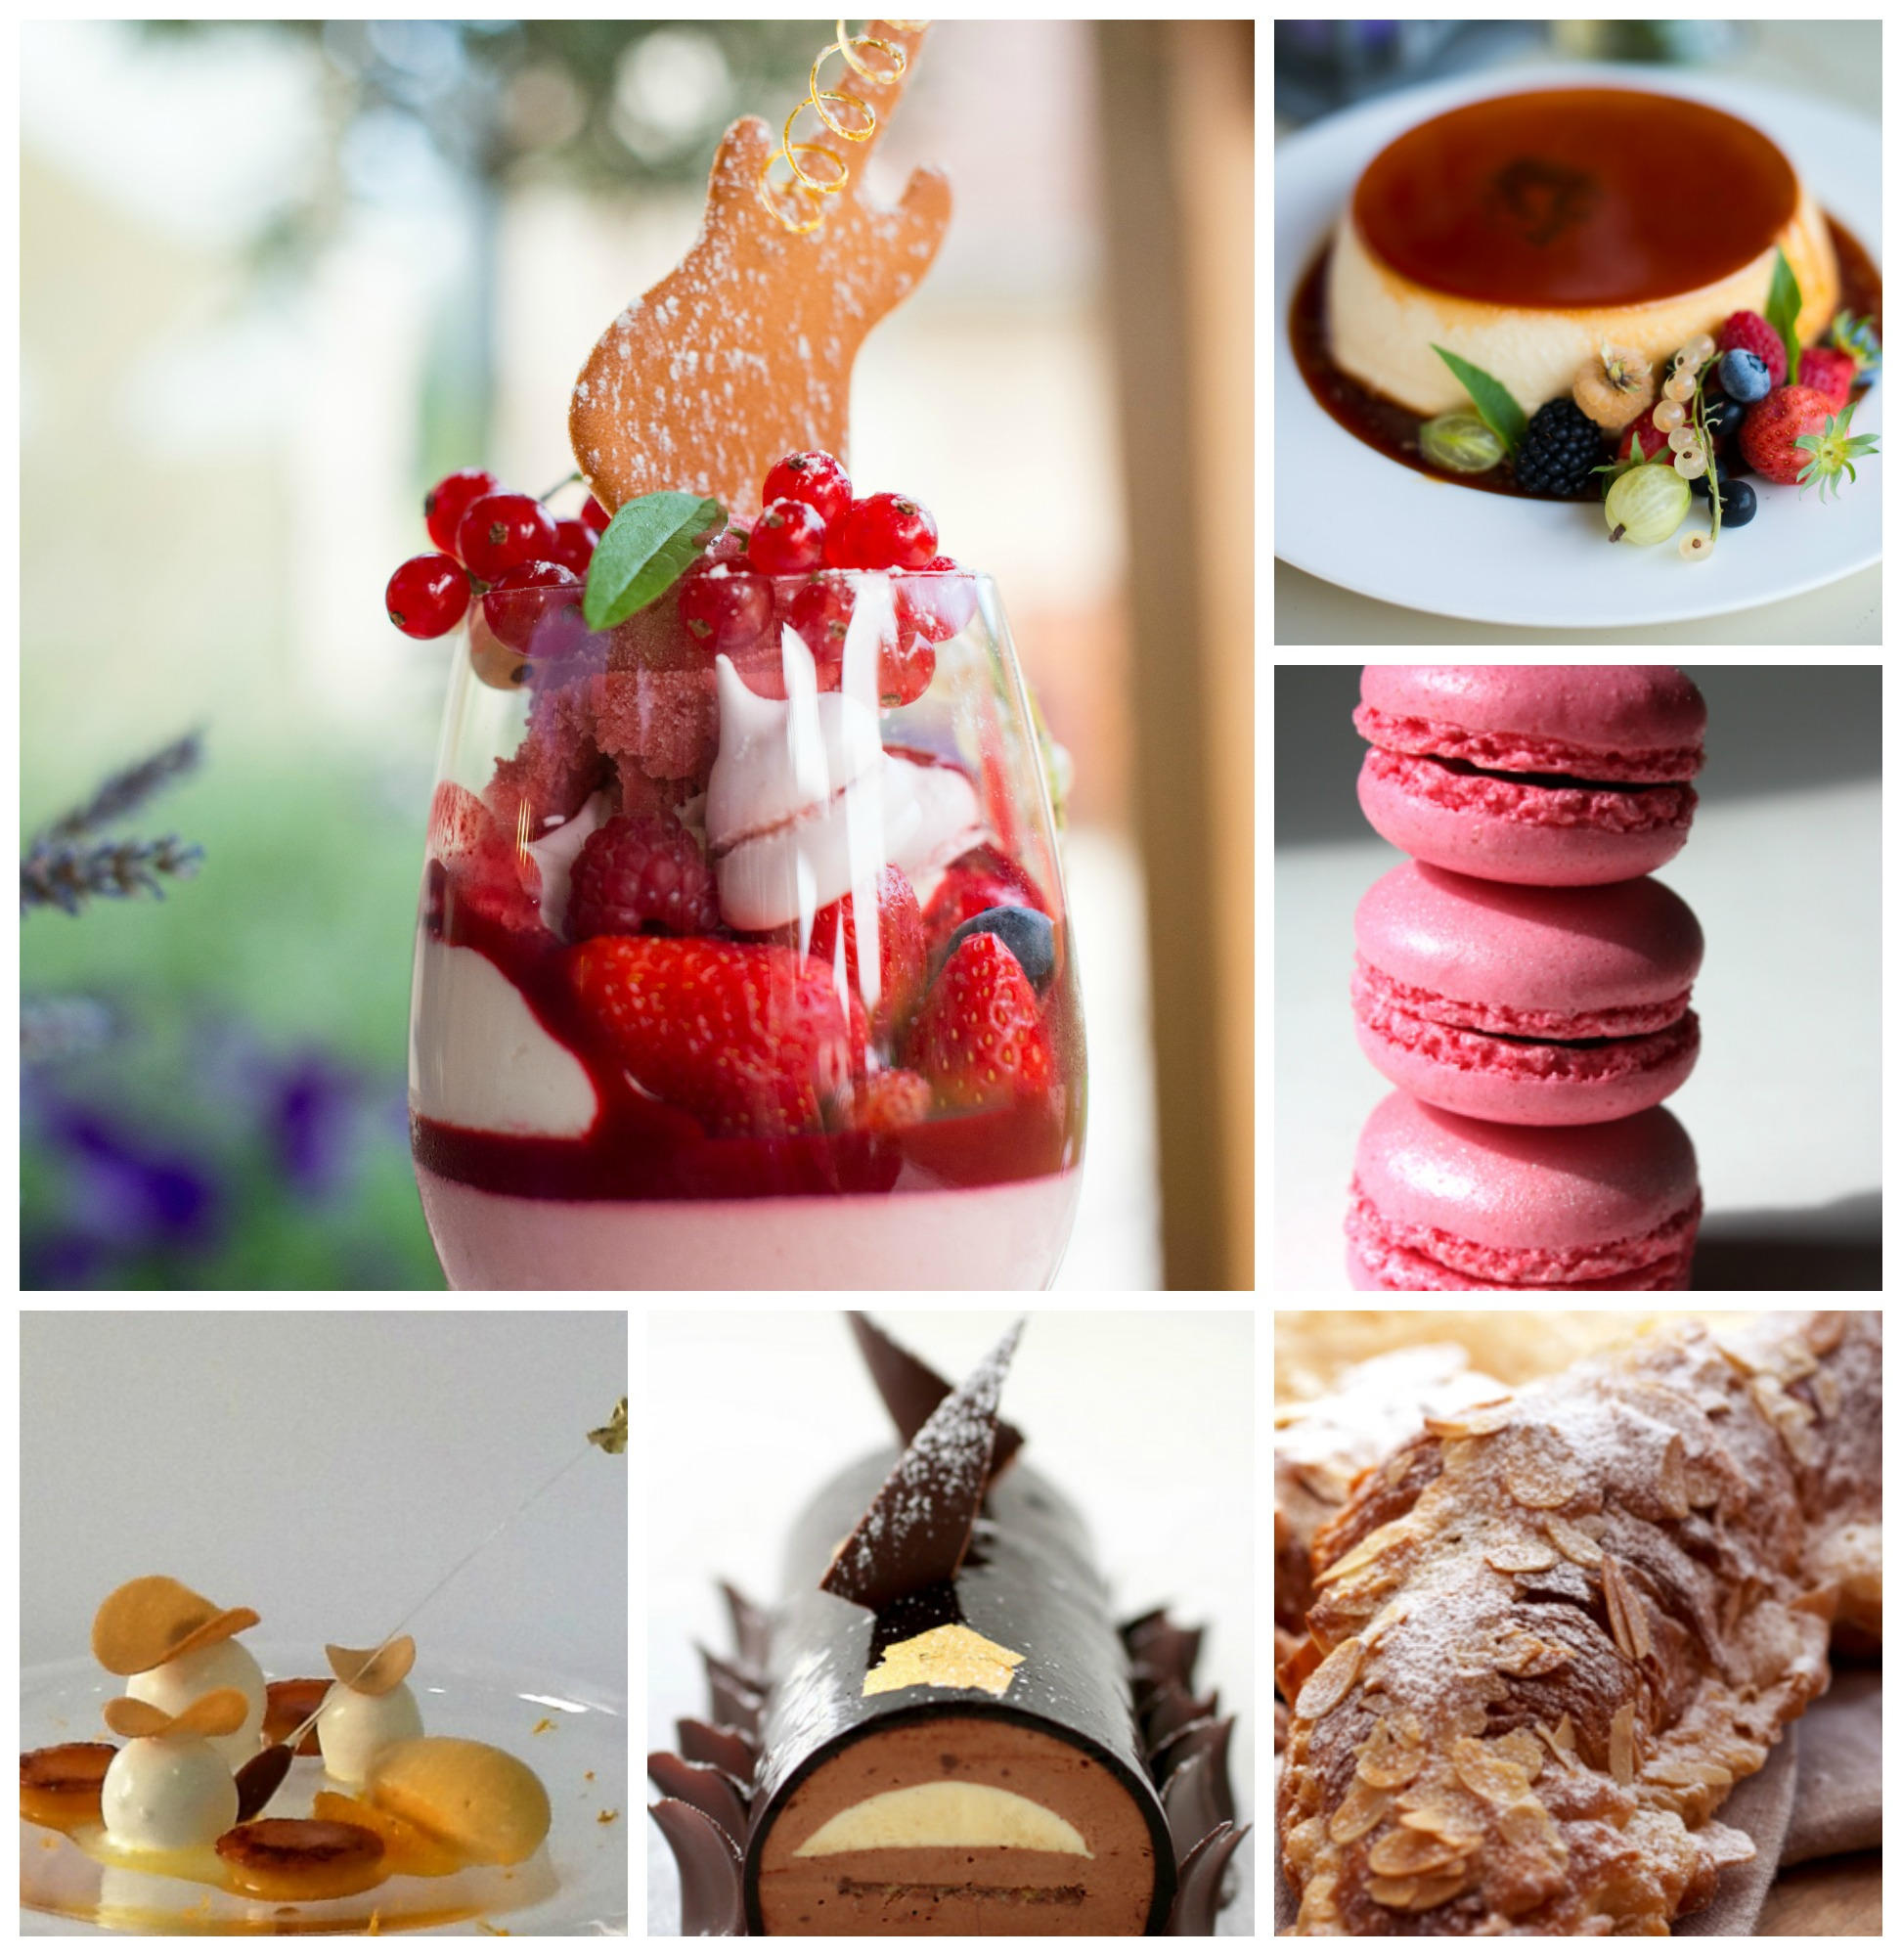

‘A French Dessert and Pastry Adventure’
with
le Calabash
7 Days / 6 Nights

Your school is set in the heart of France and The Touraine is without question the home to European Renaissance which brought with it a rich and diverse Culinary History and Depth. Your Chefs are both Qualified and Award winning chefs who have competed and won gold medals at International level as well as having cooked by demand for heads of State, Celebrities and finally on several occasions on demand for her Majesty Queen Elizabeth II.

Itinerary

Sunday Day 1

- Arrival after lunch and check into and settle into your accommodation

Dinner A welcome champagne cocktail and the opportunity to meet and get to know your fellow, Culinary Adventurers’ followed by Alison and Sidney’s ‘Taste of the Loire Valley’ dinner in the ‘Old Stable’ at le Calabash

Monday: Day 2
- Traditional French Breakfast
- This morning we will start our Pastry Adventure and master Choux Pastry, and Pâté à Sable Breton, which play an important role in pastries and dessert we prepare this week.
- We prepare bases and fillings for our Tarts, Eclairs and Profiteroles.

Lunch. We enjoy Alison and Sidney’s favourite French artisanal cheeses, Charcuterie and our freshly baked bread

- This afternoon we use our pastry we prepared this morning to create some classic, but impressive desserts with a contemporary twist!
- Tarte Crème Brulee
- Paris-Brest
- Tarte Chocolat et Caramel,
- Tarte au Citron

- Trio of Exotic Eclairs.
17.00 Leisure time till dinner.
Dinner Tonight we enjoy Sidney’s Paella around the fire. Weather permitting or in ‘The Old Barn’

Tuesday: Day 3
BreakfastTraditional French Breakfast
- This morning we will learn the art of Sorbet, Ice Cream and Frozen dessertsall which will enable you to present Restaurant Style desserts with ease.
You will also prepare Alison’s ‘Iced Passion Josephine’ a Passion Fruit and Mango dessert created for Napoleon Bonaparte’s love for Josephine.
Lunch in a traditional bistro. Today we enjoy a traditional French Style workers lunch.
This Afternoon we will make
- Tomato Bread and Coarse Salt Bread
- Brioche
- Croissants
17.00 Leisure time till dinner
- We return to Le Calabash for a Wine and Chocolate Pairing.
Chocolate is the confectionery match to wine. Perhaps this is because the process of making chocolate is very similar to wine. Both cocoa beans and wine are fermented with the very same type of yeast. No wonder there are so many wine and chocolate lovers!
Dinner Tonight is a demonstration of Sidney’s latest main course creation and one of the desserts prepared by the class

Wednesday: Day 4
Early Morning Coffee in the Garden before we depart for Tours

We visit Tours best bakery to choose our breakfast pastries which we will enjoy
in a little market coffee shop.

This morning we explore both the indoor ‘Les Halles Food Market’ and the twice weekly outdoor market.
We visit theold town which clusters around Place Plumereau; its old houses restored to their former glory. Today this is the place for pavement cafes and people watching in the summer but stroll the smaller, narrow streets like rue Briconnet and you step back into the historic medieval city. To the south you’ll find a Romanesque basilica, the Cloitre de St-Martin and the new Basilique de St-Martin. You’re in the place which was once on the great pilgrimage route to Santiago de Compostela. St-Martin was a soldier who became bishop of Tours in the 4th century and helped spread Christianity through France. His remains, rediscovered in 1860, are now in the crypt of the new Basilique.
The other old part, the cathedral quarter, on the other side of the main Rue Nationale, is dominated by the Cathédrale St-Gatien, a flamboyant Gothic building with 12th-century decorated stonework covering the outside. Inside the highlights are the 16th-century tomb of Charles VIII and Anne de Bretagne’s two children, and the stained glass.
Lunch
Today we enjoy a traditional French lunch at le Calabash, prepared by Alison.
This afternoon we will explore the chocolates and couvertures of the world as well as learn the art of chocolate work, which will include
- Tempering, Ganache and Moulding and a chocolate creation that isdesigned to impress.
17.30 Leisure time till dinner
Dinner

Thursday: Day 5

Breakfast Traditional French Breakfast

- This morning you will prepare and explore the world of,

- The Classic Tarte Tatin
- Fresh Fruit Mousses and Crèmes
- Fresh Fruit Jellies
- Italian, Swiss and French Meringue

Luncha classic Bistro styled menu.

- The Art of Macarons
Alison will share with you her passion for creating and preparing one of the world’s most sought after classics, the Macaron.
Both Classic and Contemporary.
Dinner Sidney’s Zulu BBQ

Friday: Day 6

08.30 Traditional French Breakfast

09.00 Today we will be learning and making garnishes that will enhance and ensure that your desserts are a feast for the eye. This will include Tuille work and sugar craft.

12.30 For lunch Sidney prepares you one of his latest creations.
14.30 This afternoon we prepare

- Alison’s Soufflé of the Moment
- Croquembouche
- The Art of Dessert Presentation

We finish off in the afternoon to allow you to rest or take a last walk down to the river and prepare for our last evening together.
19.30 Certificate presentation and champagne at ‘le Calabash’ and tonight you dine with the Bond’s friend, Michelin Starred, Jacky Dallay at the renowned Promenade Restaurant in le Petit Pressigny.
Saturday Day 7
Traditional French Breakfast
Departure by 11am

Le Calabash Cookery Experience includes:
- Accommodation for six nights
- Meals: daily breakfast, and meals as per itinerary, including three glasses of selected wine with meals.
- Transport for all activities in the itinerary.
- Personalised apron and recipe folder.
- Fee Wi-Fi

The price does not include:
- Transport from and to airport or station / this can be arranged
- Optional excursions or meals not listed in itinerary or any additional expenses ordered personally.
- Drinks that are personally ordered or excess wine consumed at meals
- Laundry
- Phone Calls
- Additional nights’ accommodation 195.00€ including breakfast, subject to room availability
- Spa Visit or Treatment where not included in itinerary.

6 Day ‘le Calabash’ Cookery Experience
- Residential €1975.00
- Non-Participating €1095.00
- Single Supplement €375.00

www.lecalabash.com

